
Book Appointment
Gastropexy Print Article
By Ryan Llera, BSc, DVM; Malcolm Weir, DVM, MSc, MPH; Catherine Barnette, DVM
What is a gastropexy?
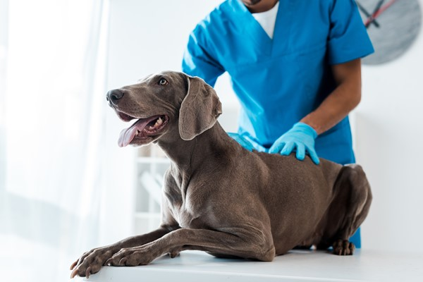 A gastropexy is a surgical procedure sometimes performed in large-breed dogs to
prevent gastric dilatation and volvulus (GDV), also known as bloat.
A gastropexy may be performed as a preventive measure as part of the surgical management of GDV to prevent recurrence after the stomach has been returned to its normal position. It may also be done in a healthy dog predisposed to this condition.
What is gastric dilatation and volvulus (GDV)?
GDV is a life-threatening condition most commonly observed in deep-chested, large-breed dogs (see handout “Bloat: Gastric Dilatation and Volvulus in Dogs”). Commonly affected breeds include Great Danes, German shepherds, standard poodles, basset hounds, weimaraners, and Irish setters.
"GDV is a life-threatening condition most commonly observed in deep-chested, large-breed
dogs."
With GDV, the stomach becomes dilated with gas and/or fluid and becomes twisted on itself, meaning that the gas/fluid cannot escape. This leads to rising pressure within the stomach, decreasing blood flow to the stomach tissues. In some cases, the spleen can also get twisted with the stomach and have its blood supply compromised as well. Disruptions in blood supply can lead to death (necrosis) of the gastrointestinal tract and spleen, and also have significant effects on blood pressure and overall health status. Without emergency treatment, GDV is fatal.
How does gastropexy prevent GDV?
During a gastropexy, your veterinarian will surgically “tack” the stomach to the right side of the body wall. This will hold the stomach in place, preventing it from making the twist that results in GDV. There are a variety of surgical techniques that can be used to perform the procedure. The most common technique involves creating an incision through the outer layer of the stomach and a corresponding incision on the inside of the body wall, where the
stomach is to be located.
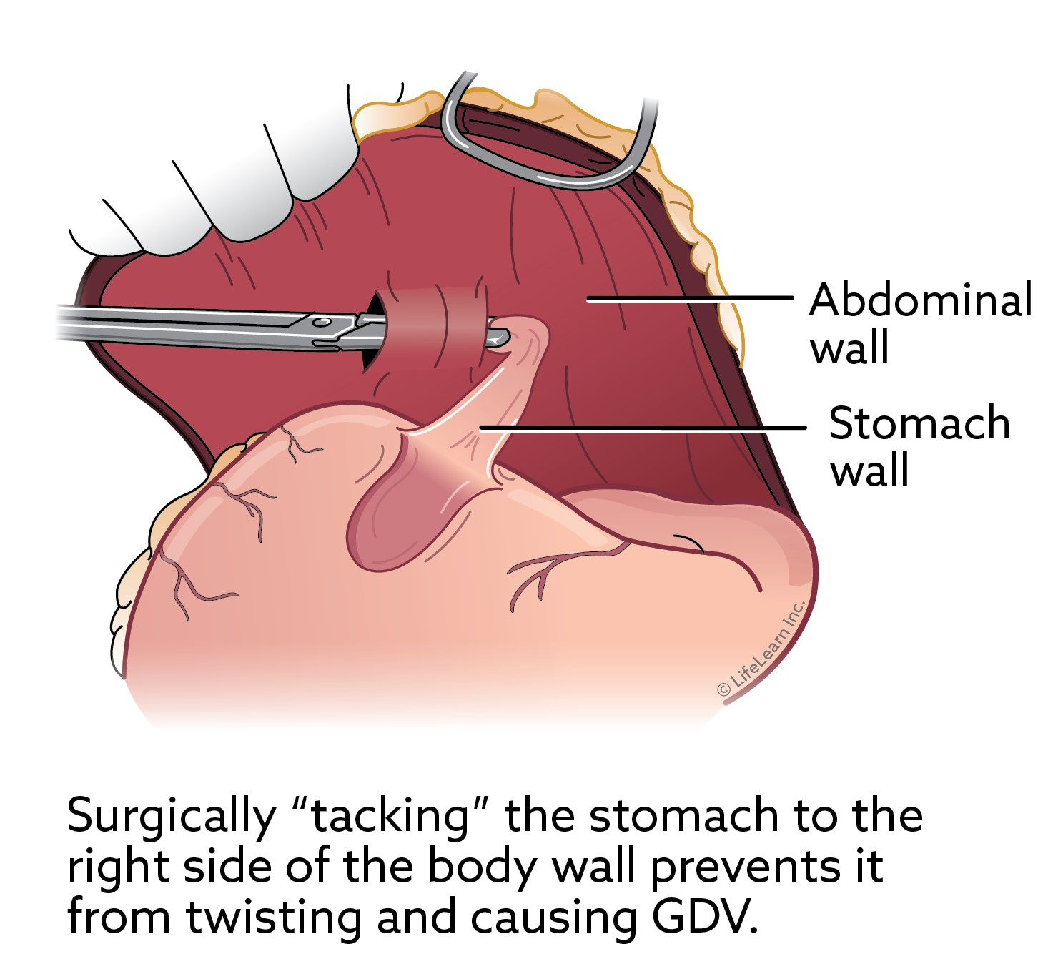 These incisions expose underlying bleeding tissue. Your veterinarian will suture the stomach
to the body wall using two lines of suture, allowing the exposed/bleeding tissue of the stomach and body wall to contact each other. As these incisions heal, they will heal together, creating a connection of scar tissue that holds the stomach in a fixed location.
A gastropexy can also be performed laparoscopically (using a camera inserted through a small incision in the body wall). Performing a laparoscopic gastropexy is less invasive, but uncommon, as this equipment is typically only available at specialty hospitals.
In what situations might my veterinarian recommend a gastropexy for my dog?
There are two primary indications for gastropexy:
- Prophylactic gastropexy. This is a gastropexy performed to prevent GDV. It is often performed in high-risk young dogs, often at the time that they are spayed or neutered. Prophylactic gastropexy is most frequently recommended in Great Danes, though it may be considered in any high-risk breed. It is estimated that 40% of Great Danes will develop GDV at some point in their life; prophylactic gastropexy significantly reduces this
likelihood.
- Gastric dilatation and volvulus (GDV). Dogs who develop GDV require emergency surgery to untwist the stomach and gastropexy is a component of this surgery. Once the stomach has been restored to its normal position, a gastropexy is performed to tack the stomach in place to prevent a
recurrence. Gastropexy reduces the risk of recurrence from 80% to less than 5%.
What post-operative care is required after a gastropexy?
With a prophylactic gastropexy, there is no specific post-operative care beyond that required for a routine spay or neuter. Patients should be kept calm for approximately 7 to 14 days post-operatively to allow healing. Running and jumping should be prevented during this time, and pets should avoid swimming or bathing so that the incision can be kept clean and dry. Your dog will likely be sent home with pain medication, and it is important to use this medication as directed.
An emergency gastropexy, performed when a dog has developed GDV, often requires more involved postoperative care, depending on the severity of stomach damage noted during surgery. Heart arrhythmias need to be monitored and controlled. Most dogs will remain hospitalized for several days postoperatively before being sent home for the remainder of their recovery period. In addition to the activity restriction required with a prophylactic gastropexy, your dog may require a prescription diet and/or medication to protect the gastrointestinal tract (such as famotidine, omeprazole, or ranitidine).
© Copyright 2024 LifeLearn Inc. Used and/or modified with permission under license.
Share
https://vcahospitals.com/know-your-pet/gastropexy 9/27/25, 7:57 AM
Page 2 of 4

